Contents
- Overview of SQL
- Types of SQL commands
- Exploring DDL Commands
- CRUD Operation
- Delete Vs. Truncate
SQL (Structure Query Language)
- SQL is used to interact with relational databases.
- An instruction written in SQL to interact with the database is called query.
- SQL is a query language.
- Core operations:
  - Store Data/ Create Data
  - Read Data
  - Update Data
  - Delete Data
Types of SQL commands
- SQL commands are divided into below categories:
  - DDL (Data Definition Language)
  - DML (Data Manipulation Language)
  - DQL (Data Query Language)
  - TCL (Transaction Control Language)
  - DCL (Data Control Language)
DDL
- These commands are given to manage database objects such as tables, views, procedure, functions etc.
- Example:
  - CREATE: Create a new database object (table, view, etc.)
  - ALTER: Modify the structure of an existing object
  - RENAME: Rename an existing database object
  - TRUNCATE: Remove all rows from a table [only data will be deleted]
  - DROP: Permanently delete a database object. [data and schema will be deleted]
DML
- Used to insert, update, or delete data within existing tables.
- Example:
  - INSERT: Add new records into a table
  - UPDATE: Modify existing records
  - DELETE: Remove data from a table
DQL
- These commands are given to fetch/read data from the database table.
- Example:
  - SELECT: Retrieve data from table
TCL
- These commands are given to control transaction.
- Example:
  - COMMIT: Permanently save all changes made during the transaction
  - ROLLBACK: Undo changes made during the transaction
  - SAVEPOINT: Set a checkpoint within a transaction to roll back to, without undoing the entire transaction.
DCL
- These commands are given to manage permission.
- Example:
  - GRANT: Give permission
  - REVOKE: Remove permission
Naming Convention
- Use lower case letters
- Use underscores (_) to separate words.
- Special characters are not allowed. [e.g. @, %, spaces, etc.]
- Avoid reserved words [e.g. SELECT, INSERT, UPDATE etc.].
Table
- Table stores data in the form of rows and columns.
- Table Schema:
  - The table schema is the structure of a table.
  - It contains Column names, Data types for each column, Column size, constraints.
- Table Data:
  - The data is the content stored inside the table.
Creating Table
Syntax:
CREATE TABLE table_name (
column1 datatype(size),
column2 datatype(size), ……..
);

Example:
Table Name: students
Column Name | Data Type | Size
roll_number | int | 10
firstname | varchar | 30
lastname | varchar | 30

CREATE TABLE students(
rollnumber int,
firstname varchar(30),
lastname varchar(30)
);

Show Table Structure
- Syntax:
DESC table_name;
- Example:
DESC students;
List All Tables
show tables;
Modifying Table
- ALTER command is used to modify table structure.
- We can use ADD, CHANGE and RENAME option with ALTER command.
Add New Column
Syntax
ALTER TABLE table_name ADD column_name datatype(size);
ALTER TABLE table_name ADD column_name datatype(size), ADD column_name datatype(size);
Example
ALTER TABLE students ADD address varchar(100);
- By default, when using the ALTER TABLE statement to add a new column to a table, the column is added at the end of the existing column list.
- To add new column at the beginning.
ALTER TABLE students ADD id int(10) FIRST;
- To add a new column at a specific position within the table, use the AFTER keyword followed by the name of the existing column.
ALTER TABLE students ADD age int(3) AFTER lastname;
Modifying Existing Column
- We can change name, data type and size of the column.
- Syntax:
ALTER TABLE employee CHANGE old_column_name new_column_name datatype(size);
- Example:
ALTER TABLE students CHANGE mark marks decimal(5,2);
Delete Existing Columns
- Syntax:
ALTER TABLE table_name DROP column_name;
- Example:
ALTER TABLE students DROP age;
Rename Table
- Syntax:
RENAME TABLE old_table_name TO new_table_name;
- Example:
RENAME TABLE students TO students_backup;
Delete Table
- Syntax:
DROP TABLE table_name;
- Example
DROP TABLE students;
Deleting All Rows from Table
- Syntax:
TRUNCATE TABLE table_name;
- Example:
TRUNCATE TABLE table_name;
CRUD
- Create
  - This operation is about creating or adding new records to the table.
  - Create data with INSERT command
- Retrieve
  - Reading data is about retrieving existing data from the table.
  - Retrieve data with SELECT command
- Update
  - The update operation modifies existing data.
  - Update data with UPDATE command
- Delete
  - This operation remove existing data from the table.
  - Delete data with DELETE command
Table: User
Columns: (id, name, age)
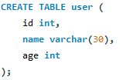
Adding Data in to Table
- INSERT command is used to add data into the table.
Case1: (Insert Data to All Columns)
- Syntax:
INSERT INTO <table_name> VALUES(value1,value2....valuen);
INSERT INTO <table_name>(col1_name, col2_name …) VALUES(value1,value2....valuen);
Explanation
  - After INSERT INTO, we put the name of the table.
  - We add the keyword VALUES followed by the actual values.
  - We need to put the values in the exact same order in which the columns appear in the database
- Example:
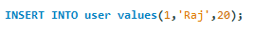
Case2: (Insert Partial Data)
- Syntax:
INSERT INTO <table_name>(colname1,colname2,..) VALUES (value1,value2...)
- Example:
Case3: (Insert Multiple Rows)
- Syntax:
INSERT INTO <table_name> values(value1,value2..),(value1,value2..),(valuen,valuen..);
- Example:
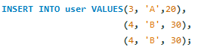
Modify/Update Data
- UPDATE command is used to update data of a table.
Case1: (Modify Single Column)
- Syntax:
UPDATE <table_name> SET col1=value WHERE condition;
- Example:
- By default SQL safe mode is enabled in MySQL work bench
Go to edit preference SQL editor Unchecked Safe mode checkbox close and start MySQL workbench.
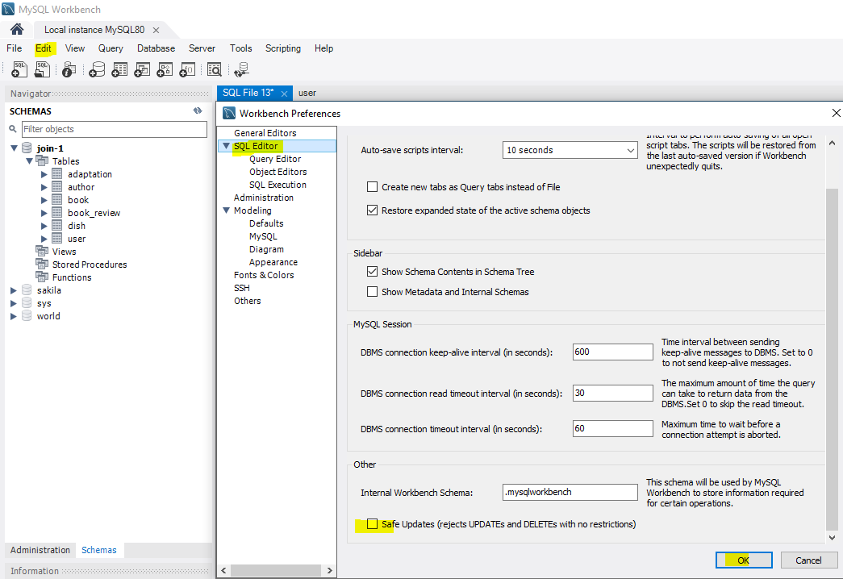
(OR)
SET SQL_SAFE_UPDATES=0;
Case2: (Modify Multiple Column)
- Syntax:
UPDATE <table_name> SET col1=value,col2=value WHERE condition;
- Example:
Case3- (Update All Rows)
UPDATE user SET age=30;
Delete Data
- DELETE command is used to delete data from a table.
Case1: (Delete Specific Rows)
- Syntax:
DELETE FROM <table_name> WHERE condition;
- Example:
Case2: (Delete All Rows)
- Syntax:
DELETE FROM <table_name>;
- Example:
Retrieve Data
- SELECT command is used to retrieve data from the table.
Appraoch1: (All Rows + All Columns)
- Syntax:
SELECT * FROM <table_name>;
SELECT colname1,colname2,colname3 FROM <table_name>;
- Example:
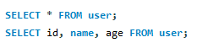
Appraoch2: (All Rows + Specific Column)
- Syntax:
SELECT colname1 FROM <table_name>;
- Example:
Appraoch3: (Specific Rows + All Columns)
- Syntax:
SELECT * FROM <table_name> WHERE condition;
- Example:
Appraoch4: (Specific Rows + Specific Columns)
- Syntax:
SELECT colname1, colname2 FROM <table_name> WHERE condition;
- Example:

Delete Vs. Truncate
 | Delete | Truncate
Purpose | Delete selected rows or all rows | Delete all rows
Where clause | Allowed | Not allowed
Type of command | DML | DDL
Rollback | Supported | Not supported
Trigger | Delete trigger fire | Delete trigger not fire
Speed | Slow, Logs each row deletion | Fast, does not log row deletion
AUTO_INCREMENT | Does not reset AUTO_INCREMENT counter | Reset AUTO_INCREMENT counter

Binary Logs
- SHOW BINARY LOGS;
- SHOW BINLOG EVENTS IN 'LAPTOP-4D9KAJCM-bin.000389';
Auto Increment
CREATE TABLE employee (
id INT AUTO_INCREMENT PRIMARY KEY,
name VARCHAR(50)
);

INSERT INTO employee(name) VALUES ('A'), ('B'), ('C');

select * from employee;

delete from employee;
truncate table employee;

